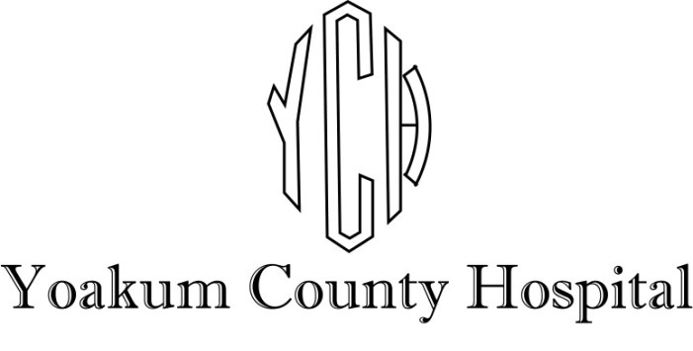

Searching for dynamic professional people to join our healthcare team.

* **Human Resources Generalist, Full Time**
* **Infection Control & Employee Health Nurse, Full Time**
* **Housekeeping, Part-Time & Full Time**
* **Dietary, Part-time**
* **Registered Nurse (Nights), Full Time**
* **ER Mid-Level Practitioner, Full Time**
* **Certified Surgical Technologist, Full Time**

YCH provides a comprehensive benefit package that includes employer-paid Cancer and Life Insurance, 80% employer paid Group Health Insurance, employer matched 200% on retirement with TCDRS, optional Dental, Vision, Flex Plan, and ICU coverage also available.

To apply, submit application online, by email, or by fax:

<https://ych.us/careers/>



[HR@ych.us](mailto:HR@ych.us)

(806) 592-4440