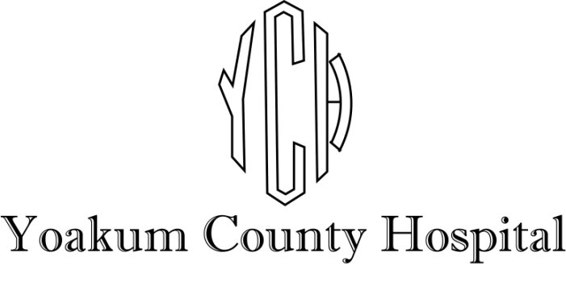

Searching for dynamic professional people to join our healthcare team.

- Chief Executive Officer, CEO
- Dietary Aid- Part Time
- RHC Mid-Level Practitioner, Full Time- Plains Clinic
- ER Mid-Level Practitioner, Full Time
- Charge Nurse, Full Time
- Certified Scrub Tech, Full Time
- Dialysis Registered Nurse - PRN
- Registered Nurse - OB (rotating shifts) - Full Time
- Registered Nurse- ER (rotating shifts)- Full Time
- ER Registration Clerk & Certified Nurse Aide (rotating shifts) - Full Time

YCH provides a comprehensive benefit package that includes employer-paid Cancer and Life Insurance, 80% employer-paid Group Health Insurance, employer-matched 200% on retirement with TCDRS, optional Dental, Vision, Flex Plan, and ICU coverage also available.

To apply, apply online, by email, or by fax:

https://ych.us/careers/

HR@ych.us

(806) 592-4440

